s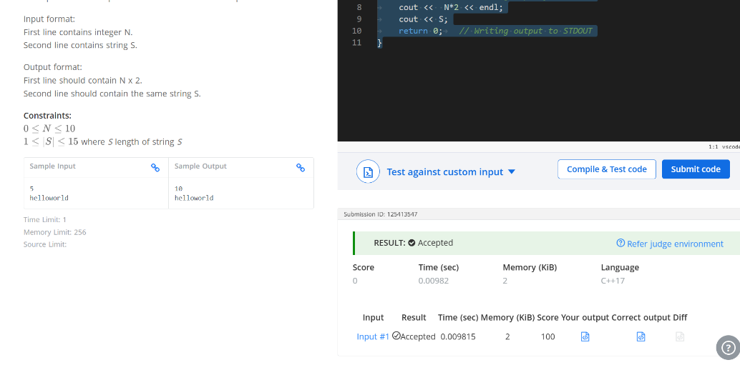

Q Read from STDIN, Write to STDOUT
#include <iostream>
using namespace std;
int main() {
int N;
string S;
cin >> N;
cin >> S; //Reading input from STDIN
cout << N*2 << endl;
cout << S;
return 0; // Writing output to STDOUT
}

